Word processing software is used to manipulate a text document, such as a resume or a report. You typically enter text by typing, and the software provides tools for copying, deleting and various types of formatting. Some of the functions of word processing software include:

Creating, editing, saving and printing documents.

Copying, pasting, moving and deleting text within a document.

Formatting text, such as font type, bolding, underlining or italicizing.

Creating and editing tables.

Inserting elements from other software, such as illustrations or photographs.

Correcting spelling and grammar.

 Text editors serve a very different purpose from word processing software. They are used to work with files in plain text format, such as source code of computer programs or configuration files of an operating system. An example of a text editor would be Notepad

Macros is a small program or command that automates common tasks.

if we find ourselves doing a certain task repeatedly, we could use a small script or something to create a macros and use a certain keyboard combination to execute that task.

**TASK 2:**

describe an object:

**Smartphone: this is the digital world**

 A smartphone is a cellular telephone with an integrated computer and other features not originally associated with telephones, such as an operating system, web browsing and the ability to run software applications.

Make and receive phone calls text messages.

Capture , view , and store pictures and video.

Browse the Internet, as well as send and receive e-mail.

GPS capability for location and navigation.

Record and play audio and music.

Display time and date and other functions such as alarm clock, stopwatch, and timer.

Display weather and temperature information.

Voice dictation and take notes.

Virtual assistant using Siri, Google Assistant, or Cortana.

Access utilities, such as a flashlight, e-book reader, and calculator.

Mobile phones have microprocessor (), similar to those in computers, but optimised to operate in low power environments.

smart phones is an IOT.

internet connectivity;

a mobile browser;

the ability to sync more than one email account to a device;

embedded memory;

a hardware or software-based QWERTY keyboard;

wireless synchronization with other devices, such as laptop or desktop computers;

the ability to download applications and run them independently;

support for third-party applications;

the ability to run multiple applications simultaneously;

touchscreen;

Wi-Fi;

**features:**

long lasting battery

Warp-speed processing

Crystal-clear display.

A great camera.

NFC. - near field communication

Multiple windows/usage of multiple apps at the same time

Plenty of storage space (with expandable storage).

*(Infrared remote control.)

Web Surfing:

The smartphones also make it convenient for people to surf the web. These devices are integrated with mobile browsers that enable them to research and access websites anytime and anywhere.

Camera:

the smartphones also allow the user to capture, view and store the photos.

entertainment:

the smartphones are also viewed as a source of entertainment. we can play games, etc....

1) Usually, with a smartphone , the input is provided using a touch screen interface and the output is seen on a screen.

 for example to book a ride on ola , the first step is to download the application from the playstore. User input is actually when the user books the ride using the touch screen interface and the output is that the user can take the ride using ola appication.

 to ci te another example,to video call on Google Duo, first step is download the application from play store. user input is actually when the user selects the contact of the person he desires to video call using the touch screen interface and the output is that the user can video call and experience High quality video calling on Duo.

 to site another example, for entertainment user can download whatever entertainment apps he desires to use, from the play store and the input is given on the touch screen interface by touching a icon and using the app for entertainment or education purposes.

**If closely perceived, the whatever the input is , the input is given using the touch screen interface. and output is seen on the screen of the mobile or whatever the device is .**

2) yes , in notebook

3) specifications and attributes of a smart phones

**Material type:**

Brand

Dimensions (mm)

Weight (g)

Battery capacity (mAh)

Removable battery

**Display**

Screen size (inches)

Touchscreen

Resolution 720x1280 pixels

**Hardware**

Processor 1.2GHz quad-core

Processor make Qualcomm Snapdragon 410

RAM

Internal storage 16GB

Expandable storage Yes

Expandable storage type microSD

**Camera**

Sensors, lens and image processor.

Rear camera 13-megapixel

Rear flash Dual LED

Front camera 5-megapixel

**Software**

Operating system Android 5.1.1

Connectivity

other features:

Wi-Fi

Wi-Fi standards supported 802.11 b/g

GPS

Bluetooth Yes, v 4.00

NFC

Infrared

USB OTG

Headphones 3.5mm

FM

Number of SIMs

Wi-Fi Direct

Mobile High-Definition Link (MHL)

3G/4G LTE

**Sensors**

Compass/ Magnetometer

Proximity sensor

Accelerometer

Ambient light sensor

Gyroscope

Barometer

Temperature sensor

4) Abstraction relating to smartphone:

Abstraction means ‘identifying and extracting relevant information to define main idea(s).’ Computer Science uses abstraction to analyse details in order to learn more about a concept as a whole. Analysing, or abstracting, the details of an object’s specific inputs and outputs functions, and attributes tells more about the category of the object as a whole.

Abstraction is essentially giving only the necessary info. To the real world user and the rest remain hidden from the user. So basically, abstraction is representation of essential features without including the background details or explanation.

 The typical smartphone user does not know how calls are made, or how the phone accesses the Internet, or even how data is stored in the phone. Instead, the mobile or smartphone user is provided with an interface that hides these details from them. Making a call simply involves selecting a contact's phone number. Accessing the Internet involves using touch screen interface to select te browser and browse the internet.

EVERYTHING IS AVAILABLE ON TOUCH SCREEN INTERFACE, JUST WITH ONE CLICK ON THE ICON.

So the background info abut how these functuons are performed internally isn’t avallable to the use.

An example in the real-world is a mobile or smartphone. The typical smartphone user does not know how calls are made, or how the phone accesses the Internet, or even how data is stored in the phone. Instead, the mobile or smartphone user is provided with an interface that hides these details from them. Making a call simply involves selecting a contact's phone number. Accessing the Internet involves selecting an icon on the screen.

The user does not need to understand the details of how a phone call is placed or how the Internet works. These details are abstracted away from the phone's interface in order to make the phone easier and more effective to use. **The design of the mobile or smartphone clearly separates the interface from the implementation**. The user can learn the functions of the phone without ever having to know anything about how the phone works internally.

Week 3: nanaogram

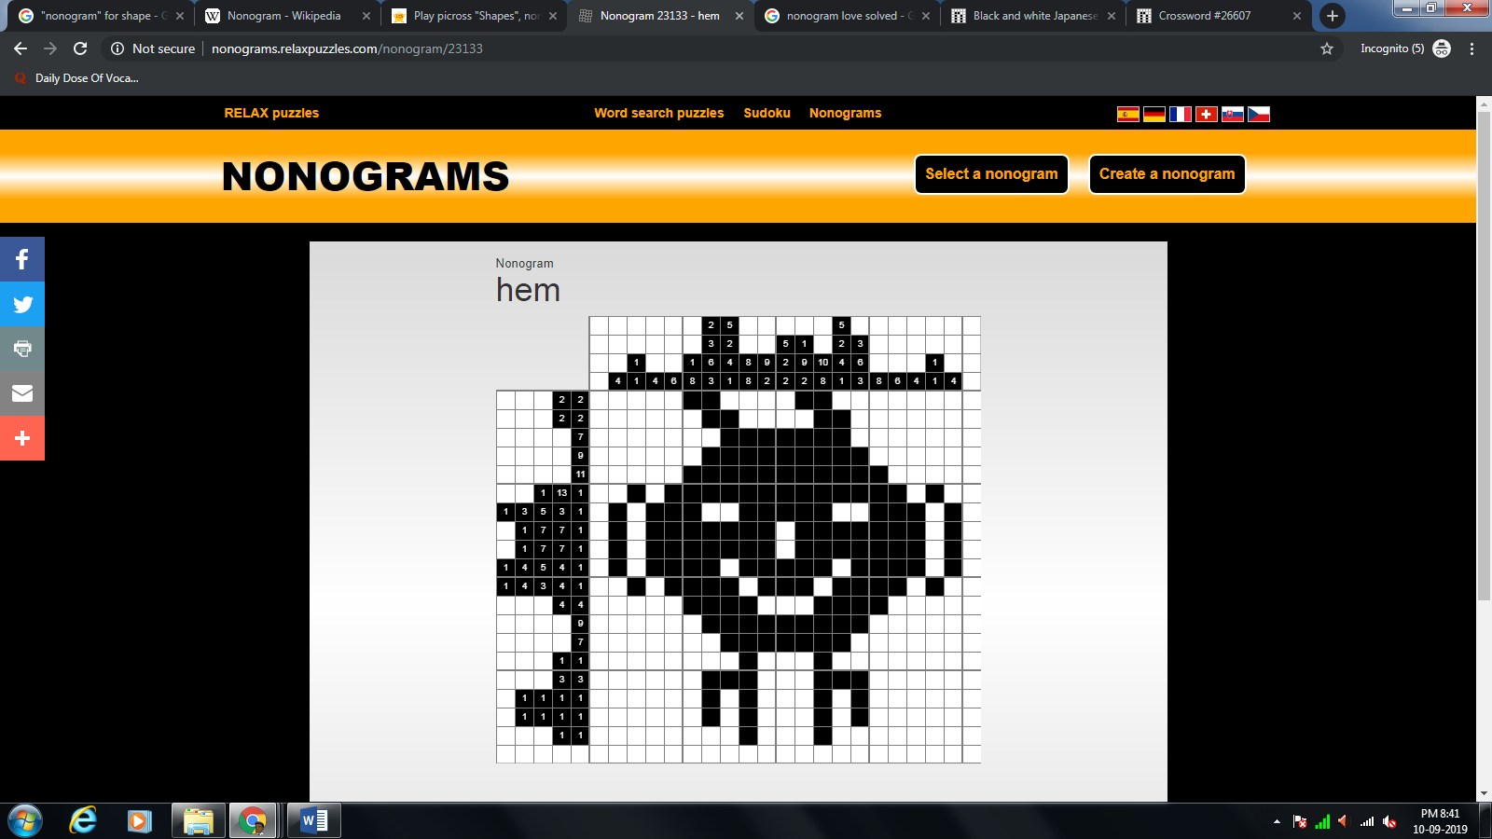

**Then a) Solve the following puzzle:**

|  |  |  |  |  |  |  |  |  |  |
| --- | --- | --- | --- | --- | --- | --- | --- | --- | --- |
|  | **3** | **2** | **1,5** | **2, 2, 1** | **4** | **2, 2, 1** | **1,5** | **2** | **3** |
| **1,1** |  |  | --------- |  |  |  | **---------** |  |  |
| **1,1** |  |  |  | **---------** |  | **---------** |  |  |  |
| **4** |  |  | **---------** | **---------** | **---------** | **---------** | **---------** |  |  |
| **2,1,2** |  | **---------** | **---------** |  | **---------** |  | **---------** | **---------** |  |
| **9** | **---------** | **---------** | **---------** | **---------** | **---------** | **---------** | **---------** | **---------** | **---------** |
| **1,5,1** | **---------** |  | **---------** | **---------** | **---------** | **---------** | **---------** |  | **---------** |
| **1,1,1,1** | **---------** |  | **---------** |  |  |  | **---------** |  | **---------** |
| **1,1** |  |  |  | **---------** |  | **---------** |  |  |  |

1. start
2. declare variable a, b, answer, , guess, counter
3. initialize variable a=1 and b=n+1 , and guess=(a+b)/2
4. assign a random value between 1 and n to answer using randomize function.
5. check if guess is not equal to answer, if false goto 13
6. If 5 is true check if guess is lower than answer
7. If 6 true, assign a as guess
8. Else check if guess is higher than answer
9. If 8 true , assign b as guess.
10. Set guess=(a+b)/2.
11. Increment counter by 1
12. Goto step 5 and repeat steps 5 to 11
13. Display the value of answer as the correct answer if counter is greater than 1
14. Display number of guesses as counter.
15. Start
16. Declare variables a , b , guess
17. Initlaize a=1 and b=n+1 and guess as average of previous values of a and b
18. Check If guess is wrong
19. If 4 is true , check if guess less than answer
20. If 5 is true assign a as guess
21. If 5 is false assign b as guess
22. Set guess=(a+b)/2

Team of 10 people asked to search for an object in the dept .

Design a strategy . will this work if we have 20 or 4 people in the team. Design better strategies.